Agile Team Charter
furlink

Asia Pacific College
Humabon Place, Magallanes Village
Makati City, Metro Manila, 1232

April 2026

Agile Team Charter
Project Name | furlink
Vision | furlink's vision is to modernize and professionalize the pet grooming industry by providing a centralied digital platform that bridges the gap between pet owners and service providers.
Mission | Provide a hassle-free experience for pet owners and pet groomers through digitalized scheduling and innovative AI tools.
Primary Objectives | - Reduce Scheduling Conflicts: Minimize double booking by ensuring that each service provider does not experience booking incidents during the first three (3) months of the release.  - Improve Visibility of Pet Service Providers: Improve the visibility of small to medium-sized pet service providers by giving them a dedicated platform to showcase their services and directly connect with pet owners. Onboard and verify one (1) service provider within the first three (3) months of release, and each provider receives search engine optimization (SEO) profile dashboard to improve visibility and potential customer reach.  - Streamline the Booking Journey: Achieve 95% accuracy in understanding user requests and automate 50% of data entry for registrations and bookings. Within the first three (3) months, this will eliminate manual errors and speed up the delivery of PayMongo payment links.  - Provide Business Insights for Service Providers: Enable pet service providers to track monthly sales, customer feedback, and related insights by integrating a business analytics dashboard into the platform by August 3, 2026.
Success Criteria | - Reduce Booking Conflicts: Service providers experience no double-bookings during the first three months.  - Provider Onboarding: Successfully verify and onboard at least one local service provider by July 20, 2026.  - Visibility Boost: 100% of onboarded providers have an active, functional SEO profile dashboard.  - Process Automation: Automate 50% of data entry for bookings to eliminate manual errors.  - Request Accuracy: Achieve 95% accuracy in platform understanding of user booking requests.  - Payment Efficiency: Instant, error-free delivery of PayMongo links upon booking confirmation.  - Business Insights: Integrate a full analytics dashboard for tracking sales and feedback by February 10, 2026.  - UAT Approval: Complete User Acceptance Testing with all critical bugs resolved by August 31, 2026.
Project Team
Name |  | Role | Responsibility | Email
Lalainne Andaya |  | Project Manager | Project coordination, stakeholder communication | lcandaya2@student.apc.edu.ph
Atasha Frances Gayle Doria |  | Lead Developer | Architectural design, frontend/backend integration | asdoria@student.apc.edu.ph
Feliz Angelica Salting |  | Release Manager and Team Lead | Manage day-to-day development activities | fpsalting@student.apc.edu.ph
Michelle Reina Pineda |  | QA Lead | Testing procedures, bug management | mbpineda@student.apc.edu.ph
Rules of Behavior
Contribution
- Active Engagement: Every team member must commit to communicating clearly and actively, ensuring everyone shares the necessary updates required for project progress.
- Feedback Integration: Everyone must actively respond to feedback given by the team, project advisers, or the steering committee.
- Active Contribution: Every team member must contribute to the charter and sprint planning to maintain a sense of ownership.
- Proactive Innovation: Every team member must take the initiative to bring realistic new ideas that push the boundaries of the platform’s current capabilities.
Transparency
- All blockers must be reported during Daily Stand-ups to ensure the schedule remains on track.
Accountability
- Quality and Assurance: Every team meber must provide results that exceed expectations, ensuring the work is accurate to minimize the need for re-work.
- Active Accountability: Team members are responsible for moving their own OpenProject work packages to Closed after the work has been tested and verified
Professionalism
- All internal and external communication must follow the standards defined in the project’s Communication Plan

Team Communication
As an Agile team, we prioritize interpersonal communication over formalized documentation.
- We will conduct daily stand-up meetings via the PROJMAN group channel to discuss progress and immediate blockers.
- We will make every effort to attend all scheduled meetings in person or online, in exception for members who feel unwell/sick.
- The team will update tasks on OpenProject.
- Meeting minutes must be provided within 24 hours after the meeting.
- If a meeting is cancelled or additional meetings are required, the project team lead will send out notification as soon as possible.
- All team members are expected to be on time for all meetings.

Sponsor Acceptance
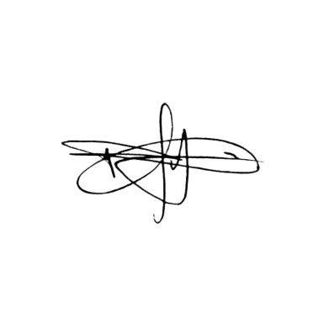
Approved by the Project Sponsor:

Date: April 7, 2026
Manuel R. Doria Jr.
Project Sponsor Representative

